Lesson 4
Paper chromatography. Drug metabolism.
Paper chromatography is a method for analyzing the composition of a test sample. It was discovered in 1944 by Conston, Gordon, Martin and Sing, who used it to analyze mixtures of amino acids. Martin and Sing were subsequently awarded the Nobel Prize for their discovery of partition chromatography. In the next 10 years, this method has become very widespread, but since 1952 paper chromatography began to be replaced by a new method of thin layer chromatography (which is essentially a generalization of paper chromatography). The latter turned out to be more effective due to the greater speed of the experiment, suitability for preparative purposes, and wider detection capabilities. Therefore, now paper chromatography is practically not used anymore, and its methods have not been improved for a long time.
General concepts:
Stationary phase - eluent, film-coated solid support;
Mobile phase - a flow of liquid, fluid or gas, moving the components of the mixture being separated along the stationary phase.
Sorption is the phenomenon of concentration of a substance in one of the adjacent phases.
Adsorption is the concentration of a substance (liquid or gas) on the surface of a solid phase.
Absorption is the absorption of a substance (gas or liquid) by a liquid.
Sorbents are solids or liquids that selectively absorb (sorb) gases, vapors or dissolved substances from the environment.
Elution is the extraction of a substance by washing it out with a suitable solvent - an eluent.
Paper chromatography is a variant of partition chromatography in which a special filter paper serves as the stationary phase carrier. The mobile phase moves through the paper under the action of capillary forces. During movement, the mobile phase dissolves the substances deposited on the paper and moves them with it.
The division of the components of the mixture is achieved due to the different speed of their movement, depending on the value of the distribution coefficient between the mobile and stationary phases.
Paper chromatography, as well as chromatography in general, can be divided into partition, adsorption and ion exchange, as well as preparative and analytical. In partition paper chromatography, normal and reversed-phase chromatography can be distinguished. In the latter case (in contrast to the normal approach), the stationary phase is more lipophilic than the mobile phase. This method is used to separate lipophilic substances.
In distributive BC, the carrier of the stationary phase is cellulose in the form of sheets of paper, which, even when dried, contains a significant amount of bound water. Distribution occurs between bound water and solvent, although adsorption effects are also present. High-quality paper is used for BH, which can be modified in accordance with the tasks set. Fiberglass paper is also used, which is resistant to corrosive chemicals and has a low adsorption capacity.
One of the earliest ways to modify chromatographic paper is acetylation. The paper obtained in this way is used for reverse phase chromatography. Later it was found that this paper is also suitable for separating racemic mixtures, since cellulose acetate itself is a chiral substance and therefore enantiomers move through it at different speeds. Silicones are also used as carriers for the stationary lipophilic phase.
According to the direction of movement of the mobile phase, three methods of chromatography are distinguished - circular, descending, ascending.
Spots on chromatograms can be detected by color, fluorescence, by chemical reactions, for which paper is sprayed or dipped in various reagents, or by radioactivity. Identification is usually carried out by comparison with samples with known Rf values or after elution, which consists in cutting out the zone containing the spot and then washing it with an appropriate solvent.
The rate of movement of a substance on a chromatogram is estimated from the relative retention value.
Rf = distance from the starting line of the chromatogram to the center of the spot of the substance / distance traveled by the front of the mobile phase
RS= Rf(analyte)/ Rf(reference).
Identification.
The main spot on the chromatogram obtained for the test solution is compared visually with the corresponding spot on the chromatogram obtained for the standard sample solution (reference solution), comparing the color (fluorescence color), size and relative retention of both spots.
Metabolism of drugs.
Drugs that have entered the body are xenobiotics for it, i.e., foreign agents, therefore, they are subject to excretion. The complex of physicochemical and (or) biochemical reactions, as a result of which the drug is converted into a more polar (water-soluble) compound, i.e., a product that is more easily excreted from the body, is called biotransformation.
+ As a rule, the chemical compounds formed as a result of the biotransformation of drugs are less active and less toxic, however, the formation of both more toxic and more pharmacologically active compounds is possible (as a result of the biotransformation of cortisol, a pharmacologically more active hormone, hydrocortisone, is formed, and as a result of the biotransformation of the antitussive codeine, the narcotic analgesic morphine is formed).
Biotransformation of drugs almost exclusively (90–95%) occurs in the liver. The remaining amounts are inactivated in the tissues of the gastrointestinal tract, lungs, skin and blood plasma. A certain amount of drugs is excreted from the body unchanged.
Fat-soluble drugs that easily cross biological membranes and quickly reach the target tissue are difficult to excrete from the body. A significant part of the drug filtered in the renal glomeruli, when passing through the tubules, is reabsorbed back into the blood. Therefore, only a small amount of the drug is usually excreted unchanged in the urine. To remove drugs and other foreign substances from the body, it is necessary to convert them into more hydrophilic metabolites. As a rule, in the process of metabolism, polar inactive substances are formed, which are easily excreted from the body. However, some metabolites are biologically active and sometimes toxic. In the course of many biochemical reactions, in addition to inactive metabolites of drugs, biologically active endogenous substances are formed. The general principles of drug metabolism described below apply to any exogenous and some endogenous substances (steroid hormones, vitamins, fatty acids).
There are 2 main types of transformation of drugs:
1. Metabolic transformation (phase I reactions, non-synthetic metabolic reactions).
2. Conjugation (phase II reactions, synthetic reactions of metabolism).
During phase I, a functional group is attached to the drug molecule (or this group becomes available as a result of chemical transformations). Phase I products are usually inactive, but some of them have an equally pronounced or more powerful effect, and occasionally even acquire new pharmacological properties. Sometimes the drug is administered as an inactive precursor that is rapidly converted to the active metabolite in the body (usually by hydrolysis of ester or amide bonds). This allows for a more complete delivery of the drug to the target tissue. Phase I metabolic products are excreted in the urine or interact with endogenous compounds, forming water-soluble metabolites.
During phase II, a covalent bond is formed between the functional group of the drug or its metabolite and endogenous compounds (glucuronic acid, sulfate, acetate, glutathione, amino acids). Phase II products are polar and generally inactive compounds that are rapidly excreted in the urine or feces. Sometimes active metabolites are formed in phase II (for example, morphine glucuronide has a stronger analgesic effect than morphine itself).
Chemical transformations of drugs usually occur under the action of enzymes. The most important organ responsible for the metabolism of drugs is the liver, although the enzyme systems involved in metabolic reactions are present in almost any tissue. To a large extent, drugs are metabolized in the gastrointestinal tract, kidneys and lungs. After oral and rectal administration, some drugs are inactivated in the intestinal epithelium or liver and only then enter the systemic circulation, which significantly reduces their bioavailability. Chemical transformations of drugs occur mainly in the endoplasmic reticulum and cytosol, as well as in mitochondria, the nucleus and the cell membrane. During fractional centrifugation of tissue homogenates, the endoplasmic reticulum is destroyed, and fragments of membranes form small granules - the so-called microsomes. Therefore, enzymes of the endoplasmic reticulum are often called microsomal enzymes. Phase I reactions of metabolism are catalyzed mainly by enzymes of the endoplasmic reticulum, and phase II reactions are catalyzed by cytosolic enzymes. Drugs that have undergone chemical transformation in the endoplasmic reticulum are often conjugated here or in the cytosol of the same cell.
The activity of drug-metabolizing enzymes can either increase or decrease due to many different factors, both chemical and physico-chemical in nature.
Индукторы | Ингибиторы
Этанол | Циметидин
Омепразол | Эритромицин
Фенобарбитал | Сок грейпфрута
Рифампицин | Кетоконазол
Курение | Хинидин
Гипоксия | Ионизирующее излучение

Metabolic transformation is the transformation of medicinal substances due to oxidation, reduction, hydrolysis, etc.
Oxidation is one of the most characteristic and frequent ways of drug inactivation. It is carried out in hepatocytes by a system of microsomal oxidase enzymes (the main representative is cytochrome P-450).
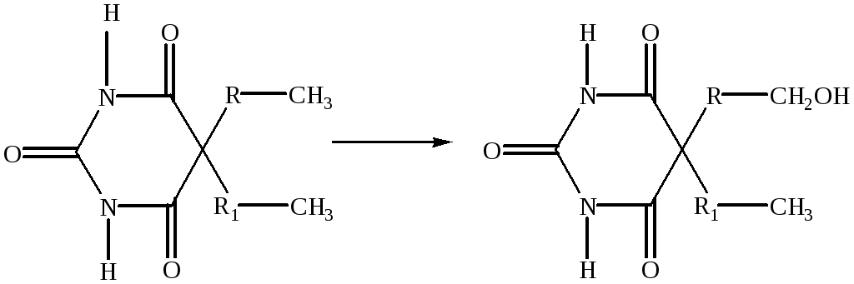
Изоформа цитохрома P-450 | Ингибирующее лекарство | Лекарства активность которых изменится  в случае ингбиции
CYP1A2 | Флувоксамин | Клозапин
 |  | Галоперидол
 | Циметидин | Клозапин
 |  | Пропранолол
 |  | Теофиллин
CYP2D6 | Амиодарон | Амитриптилин
 | Флуоксетин | Кодеин
 | Циметидин | Флеканид
 | Хинидин | Пропранолол
 | Пароксетин | Тиоридазин
CYP3A4 | Циметидин | Амиодарон
 | Эритромицин | Астемизол
 | Флуконазол | Карбамазепин
 | Индинавир | Циклоспорин
 | Омепразол | Диазепам
 | Сертралин | Фентанил

Restoration is a comparatively rare path of transformation. It is typical, in particular, for hormones of the steroid structure and their analogues. It goes in the presence of sensitive functional groups (nitro, keto or sulfoxide).
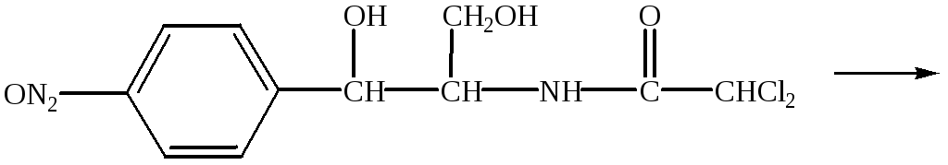
Chloramphenicol
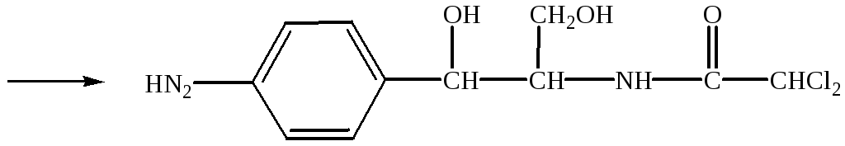
reduction of a nitro group to an amino group
Hydrolysis is a very important route for the inactivation of esters and amides, which include many drugs. In the process of hydrolysis, the ester or amide bond is cleaved with the addition of water. Can go both spontaneously (ethers and esters) and with the help of esterase enzymes
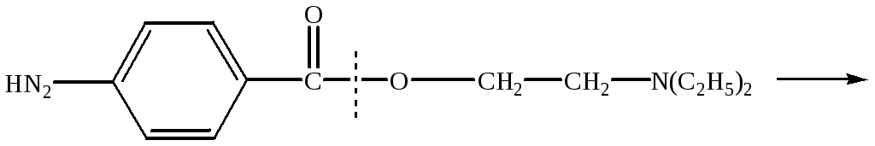
Novocaine
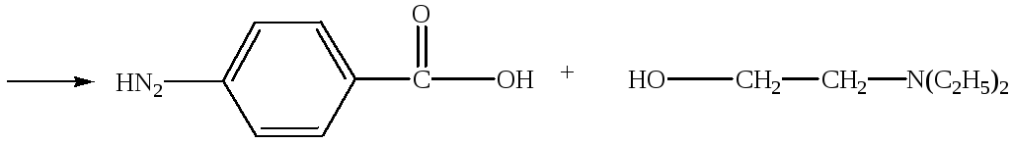
para-aminobenzoic acid diethylaminoethanol
Conjugation is a biosynthetic process accompanied by the addition of a number of chemical groups or molecules of endogenous compounds to a drug or its metabolites (methylation, acetylation, interaction with glucuronic acid, sulfates, glutathione).
Conjugation reactions are catalyzed by transferases. The most important reaction is conjugation with glucuronic acid, which occurs under the action of glucuronyltransferases. In order to enter into a conjugation reaction, drugs must first pass into the appropriate form (aromatic and aliphatic alcohols, carboxylic acids, amines); exogenous and endogenous compounds with free sulfhydryl groups also enter into these reactions. As a result, O-, N- and S-glucuronides are formed. In the form of glucuronides, endogenous substances are also excreted - steroid hormones, bilirubin, bile acids and fat-soluble vitamins. Due to hydrophilicity, glucuronides are easily excreted in the urine and bile.
Most of the phase II reactions of metabolism occur in the cytosol, but glucuronyl transferases are microsomal enzymes, so the products of the phase I metabolism occurring in microsomes undergo conjugation here. In addition to the liver, glucuronyltransferases are present in the intestinal epithelium, kidneys, and skin. In humans, 15 glucuronyltransferases have been identified, which are divided into two families. Within the family, the amino acid sequence similarity exceeds 50%. Isoenzymes 1A are encoded by one gene and are formed as a result of alternative splicing. The gene contains 12 promoters and, accordingly, 12 different first exons. Isoenzymes differ in the 1st exon, and exons from 2nd to 5th are common to all isoenzymes. Family 2 contains 3 subfamilies: 2A, 2B and 2C. The substrate specificity of individual glucuronyltransferases overlaps to a large extent, so that the same metabolite can be formed under the action of different isoenzymes.
The conjugation reaction with sulfate is also significant. In the cytosol, under the action of sulfotransferases, the sulfo group is transferred from activated 3'-phosphoadenosine-5'-phosphosulfate to the hydroxyl group of phenols and aliphatic alcohols. Thus, drugs and their metabolites containing a hydroxyl group can form both glucuronides and sulfates. Acetylation of amines, hydrazines, and drugs containing a sulfonamide group involves arylamine-N-acetyltransferase 1 and arylamine-N-acetyltransferase 2. Unlike other conjugation products, acetylated metabolites are usually less soluble in water than parent drugs, therefore, in order to avoid crystalluria it is necessary to maintain a high diuresis.
The biotransformation of drugs is directly affected by a fairly large number of factors:
1. Age (in newborns, the system of microsomal liver enzymes is very imperfect).
2. Gender (experiments on rats showed that males metabolize drugs faster, which is associated with the stimulating effect of male sex hormones on the synthesis of microsomal enzymes).
3. Genetic factors (genetically determined level of pseudocholinesterase activity).
4. Features of nutrition.
5. Bad habits (nicotine and alcohol increase the activity of microsomal enzymes and, consequently, the metabolic rate of simultaneously used substances).
6. The functional state of the liver (in case of liver pathology, the metabolism of medicinal substances is disturbed).

A prodrug is a chemically modified form of a drug (ether, salt, ester salt, etc.), which in biological media turns into the drug itself as a result of metabolic processes.
The field of prodrug development is intensively developing, and such drugs are increasingly used for targeted drug delivery to the necessary organs, tissues, etc.
